**Recent studies on substituent effects on**

**13C NMR chemical shifts**

**;**

**;**

**;**

**Purpose and scope of the present investigation**

In the present study, the substituted-5-benzylidenebarbituric acids were prepared with the following objectives.

1. To study the correlations between the Hammett substituent constants and 13C NMR substituent induced chemical shifts (SCS) of substituted-5-benzylidenebarbituric acids.
2. To study the use of SCS to monitor the transmission of electronic effects in molecular structures and to understand the mode of transmission of long-range effects in extended π-systems.

**EXPERIMENTAL**

**Preparation of Compounds**

5-benzylidenebarbituric acid and its substituted compounds were prepared by the modified procedure1.

To the calculated amount of the pure benzaldehyde (2 g, 0.015 mol) and barbituric acid (1.55g, 0.015 mol) in warm ethyl alcohol was added a 10% solution of sodium hydroxide (catalytic amount) and the reaction mixture stirred for 2 hours. After completion of the reaction as indicated by TLC, the reaction mixture was left overnight (scheme I). Solid product was separated by filtration and washed several times with cold methanol.

**CHARACTERIZATION**

All the compounds were characterized as 5-benzylidenebaarbituric acid and its derivatives by 1H and 13C NMR spectral techniques. 1H and 13C spectra were obtained on a BRUKER AMX 400 MHz spectrometer. Chemical shift of 1H were measured with the peak of DMSO at δ 2.51 as the internal reference, while those of 13C were recorded with the central peak of DMSO at δ 39.90 as the internal reference.



Fig ( )

**Assignment of 1H NMR Signals**

;

;

**1H NMR** Spectra of 5-benzylidenebarbityric acids are given below.

Compound 1*: 5-(4’-methoxybenzylidene)barbituric acid*

1H NMR: δ 3.877 (s,3H), 7.065 (d,2H), 8.252(s,1H), 8.369 (d,2H), 11.175 (s,1H), 11.302 (s,1H).

Compound 2: *5-(4’-hydroxybenzylidene)barbituric acid*

1H NMR: δ 6.878 (d,2H), 8.213 (s,1H), 8.320 (d,2H), 10.851 (s,1H), 11.117(s,1H), 11.249 (s,1H).

Compound 3: *5-(4’-methylbenzylidene)barbituric acid*

1H NMR: δ 2.385 (s,3H), 7.304 (d,2H), 8.094 (d,2H), 8.255 (s,1H), 11.218 (s,1H), 11.365 (s,1H).

Compound 4: *5-benzylidenebarbituric acid*

1H NMR: δ 7.485 (m,3H), 8.073 (d,2H), 8.285 (s,1H), 11.238 (s,1H), 11.397 (s,1H).

Compound 5: *5-(4’-chlorobenzylidene)barbituric acid*

1H NMR: δ 7.518 (d,2H), 8.069 (d,2H), 8.243 (s,1H), 11.275 (s,1H), 11.425 (s,1H);

13C NMR: δ 120.09, 128.55, 132.01, 135.15, 137.21, 150.65, 153.52, 162.04, 163.67.

Compound 6: *5-(4’-bromobenzylidene)barbituric acid*

1H NMR: δ 7.670 (d,2H), 7.979 (d,2H), 8.223 (s,1H), 11.272 (s,1H), 11.421 (s,1H).

Compound 7: *5-(4’-nitrobenzylidene)barbituric acid*

1H NMR: δ 8.017 (d,2H), 8.245 (d,2H), 8.324 (s,1H), 11.329 (s,1H), 1.504 (s,1H).

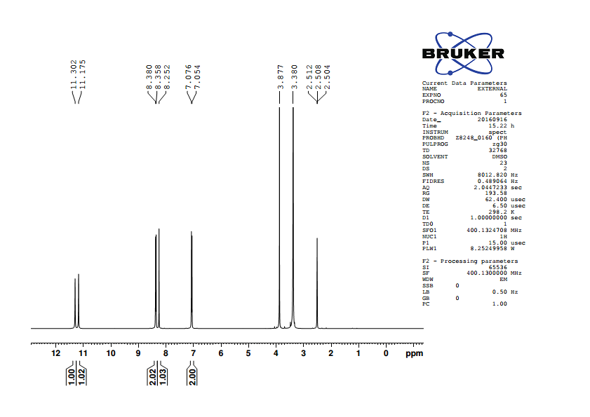

Fig. 1H NMR spectrum of 5-(4’-methoxybenzylidene)barbituric acid

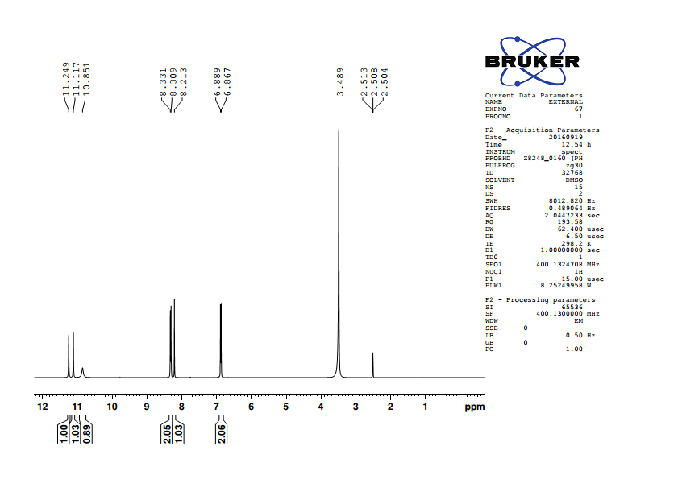

Fig. 1H NMR spectrum of 5-(4’-hydroxybenzylidene)barbituric acid

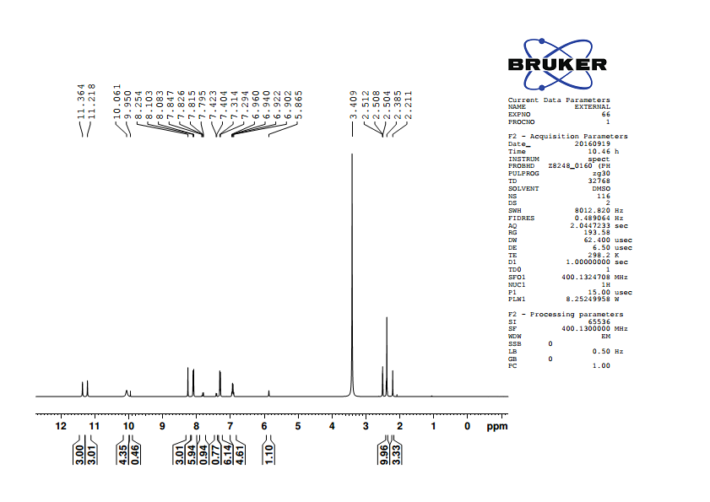

Fig. 1H NMR spectrum of 5-(4’-methoxybenzylidene)barbituric acid

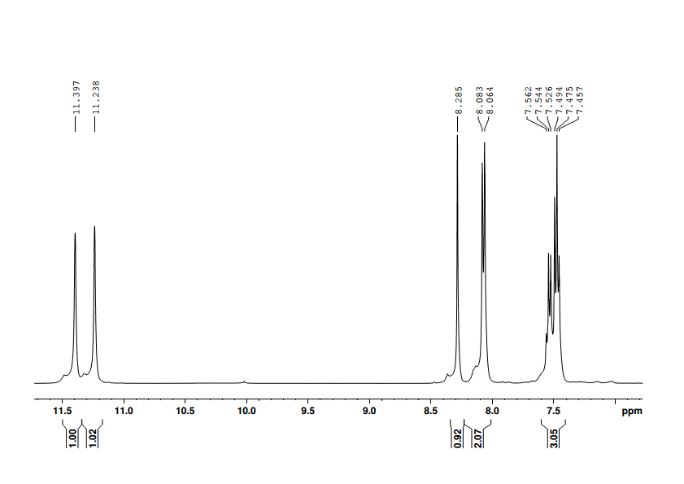

Fig. 1H NMR spectrum of 5-benzylidenebarbituric acid

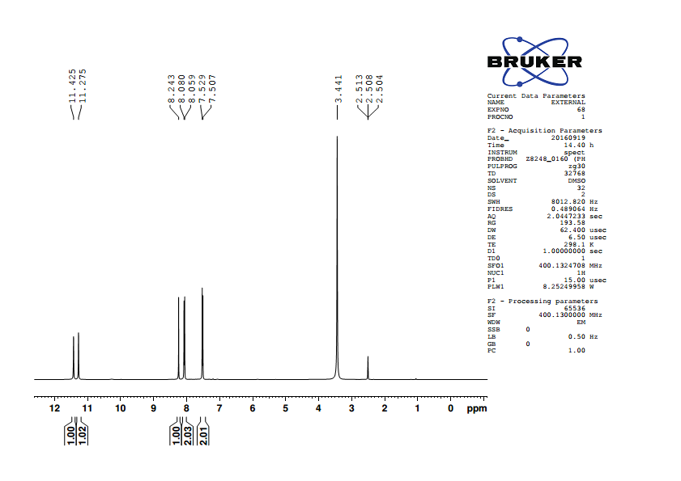

Fig. 1H NMR spectrum of 5-(4’-chlorobenzylidene)barbituric acid

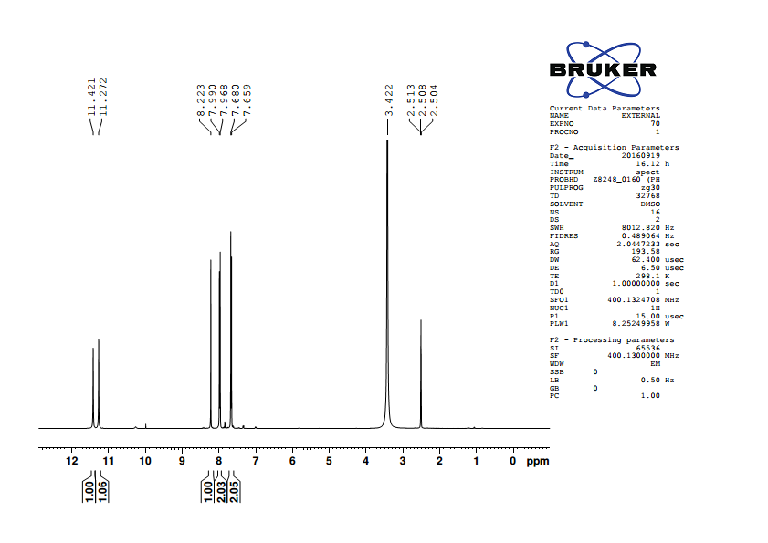

Fig. 1H NMR spectrum of 5-(4’-bromobenzylidene)barbituric acid

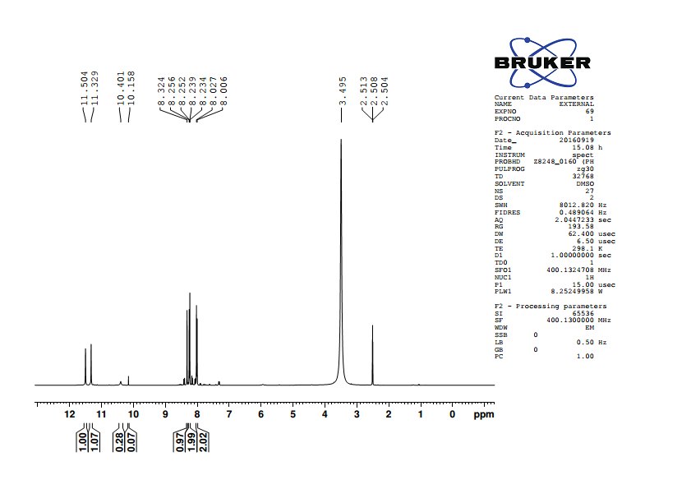

Fig. 1H NMR spectrum of 5-(4’-nitroobenzylidene)barbituric acid

**Assignment of 13C NMR signals**

**;**

**;**

**;**

**;**

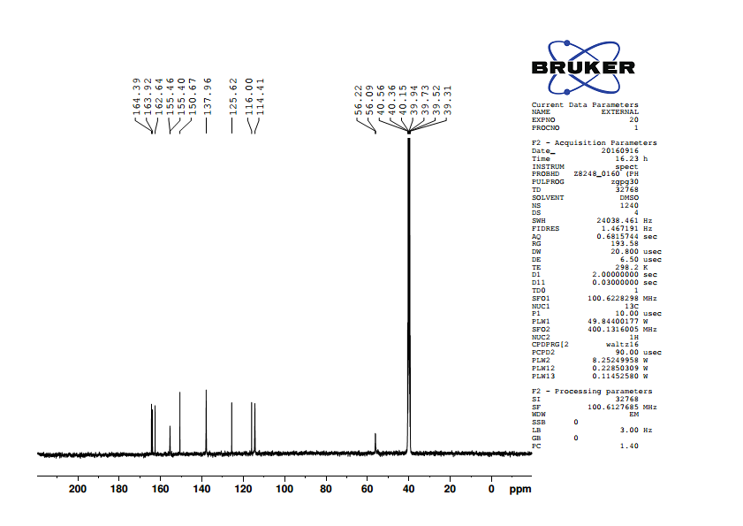

Fig. 13C NMR spectrum of 5-(4’-methoxybenzylidene)barbituric acid

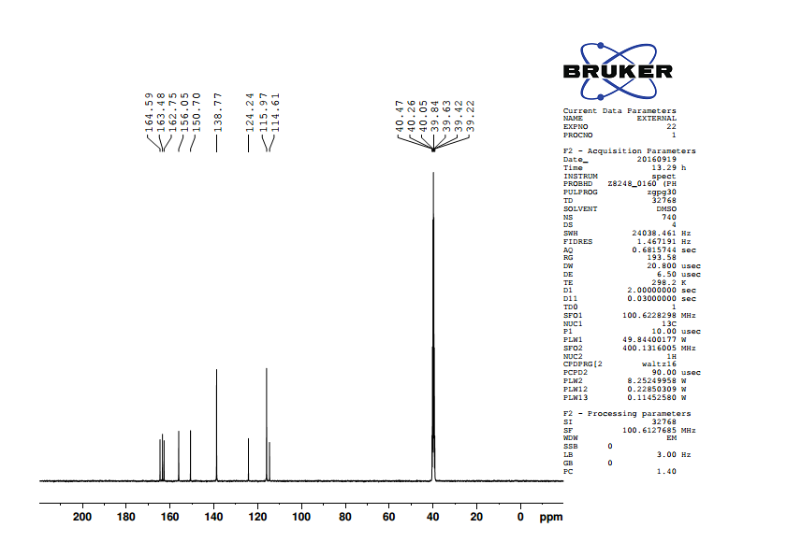

Fig. 13C NMR spectrum of 5-(4’-hydroxybenzylidene)barbituric acid

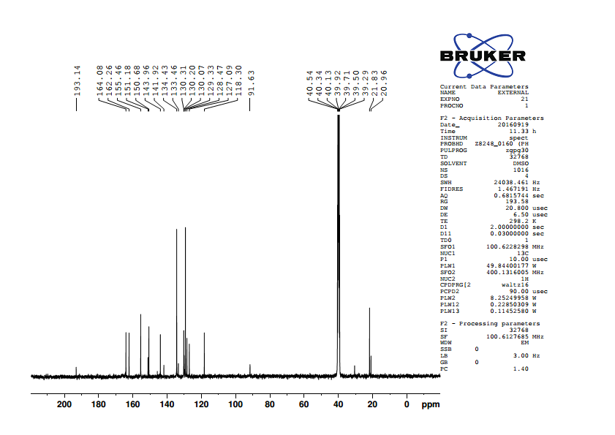

Fig. 13C NMR spectrum of 5-(4’-methylbenzylidene)barbituric acid

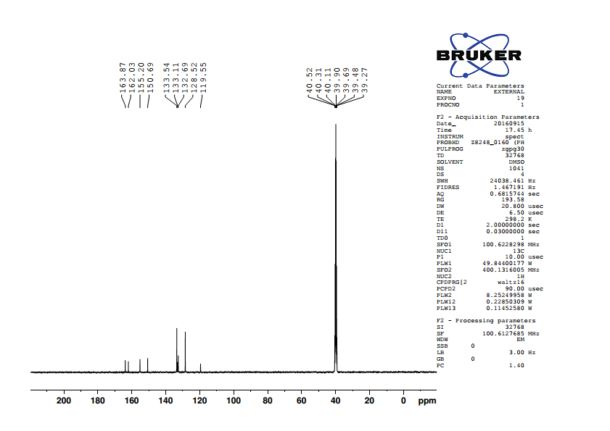

Fig. 13C NMR spectrum of 5-benzylidenebarbituric acid

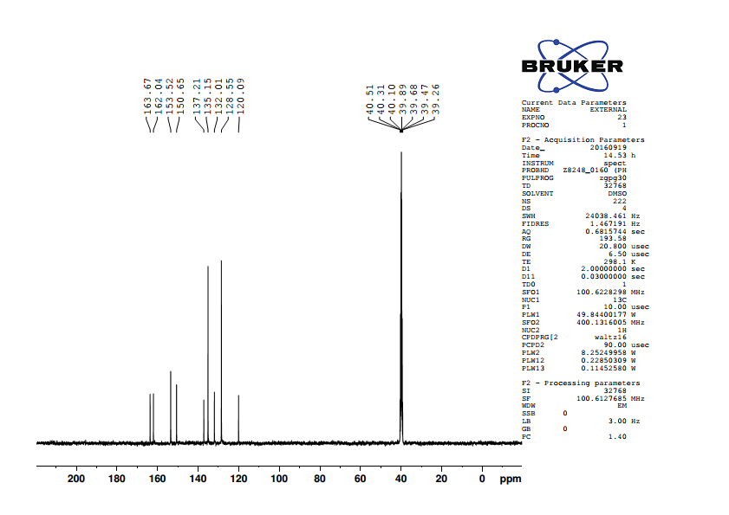

Fig. 13C NMR spectrum of 5-(4’-chlorobenzylidene)barbituric acid

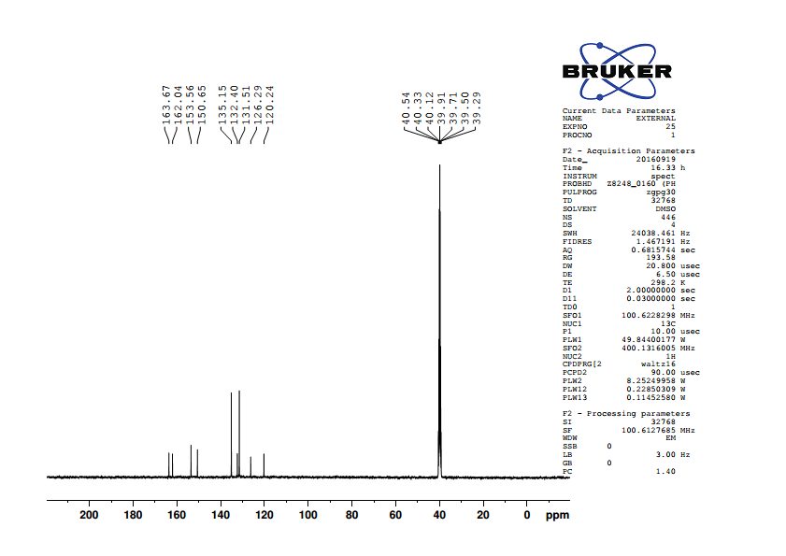

Fig. 13C NMR spectrum of 5-(4’-bromobenzylidene)barbituric acid

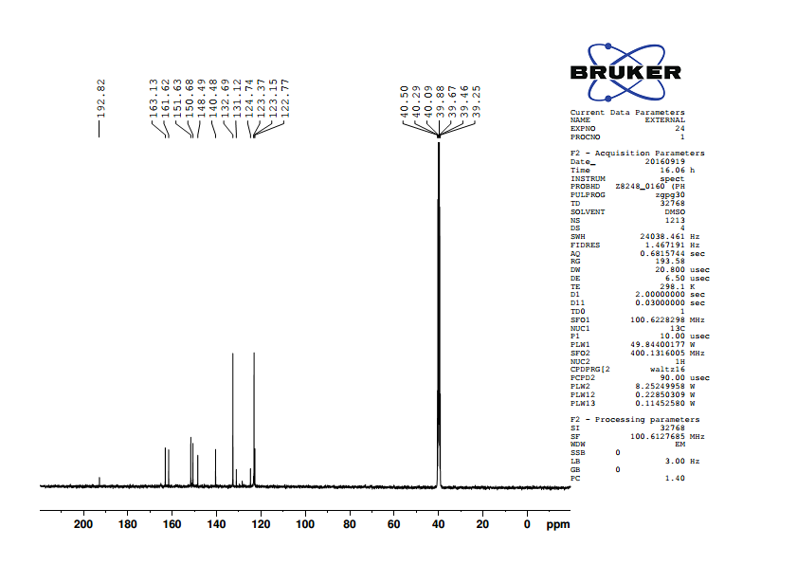

Fig. 13C NMR spectrum of 5-(4’-nitrobenzylidene)barbituric acid

**;**

**;**

**;**

**;**

**;**

**Table ( ): 13C NMR chemical shifts of substituted 5-benzylidenebarbituric acids**

|  |  |  |  |  |  |  |  |  |  |  |
| --- | --- | --- | --- | --- | --- | --- | --- | --- | --- | --- |
| **S.No.** | **GROUP** | **C1** | **C22’** | **C33’** | **C4** | **C5** | **C6** | **C7** | **C9** | **C11** |
|  |  |  |  |  |  |  |  |  |  |  |
| 1 | -OCH3 | 162.64 | 114.41 | 137.96 | 125.62 | 155.46 | 116 | 163.92 | 150.67 | 164.39 |
|  |  |  |  |  |  |  |  |  |  |  |
| 2 | -OH | 163.48 | 115.97 | 138.77 | 124.24 | 156.05 | 114.61 | 162.75 | 150.7 | 164.59 |
|  |  |  |  |  |  |  |  |  |  |  |
| 3 | -CH3 | 143.96 | 129.33 | 134.43 | 130.31 | 155.46 | 118.3 | 162.26 | 150.68 | 164.08 |
|  |  |  |  |  |  |  |  |  |  |  |
| 4 | -H | 133.11 | 128.52 | 133.54 | 132.69 | 155.2 | 119.55 | 162.03 | 150.69 | 163.87 |
|  |  |  |  |  |  |  |  |  |  |  |
| 5 | -Cl | 137.21 | 128.55 | 135.15 | 132.01 | 153.52 | 120.09 | 162.04 | 150.65 | 163.67 |
|  |  |  |  |  |  |  |  |  |  |  |
| 6 | -Br | 126.29 | 131.51 | 135.15 | 132.4 | 153.56 | 120.24 | 162.04 | 150.65 | 163.67 |
|  |  |  |  |  |  |  |  |  |  |  |
| 7 | -NO2 | 148.49 | 132.69 | 123.37 | 140.48 | 151.63 | 123.15 | 161.62 | 150.68 | 163.13 |

**RESULTS AND DISCUSSION**

**Correlations with Lynch-Equation**

**;**

**;**

**Table ( ) : Results of Lynch correlationsa of 13C chemical shifts of compound fig ( ) with SCS values for mono substituted benzenes.**

|  |  |  |  |  |  |  |  |
| --- | --- | --- | --- | --- | --- | --- | --- |
| S.No. | Carbons | Benzene  SCS  (Sb) | Slope | Intercept | rc | nd | Se |
| 1. | C1 | Si | 0.97 | 132.23 | 0.988 | 6 | 2.17 |
|  |  |  |  |  |  |  |  |
| 2. | C22’ | SO | 0.84 | 129.73 | 0.828 | 6 | 4.14 |
|  |  |  |  |  |  |  |  |
| 3. | C33’ | Sm | 0.71 | 132.69 | 0.113 | 6 | 5.63 |
|  |  |  |  |  |  |  |  |
| 4. | C4 | Sp | 0.94 | -126.43 | 0.993 | 6 | 0.61 |

1. SCSX (Y) = a + b SCSX (H)
2. SCS values in Appendix (I)
3. Correlation coefficient
4. Number of data points
5. Standard deviations

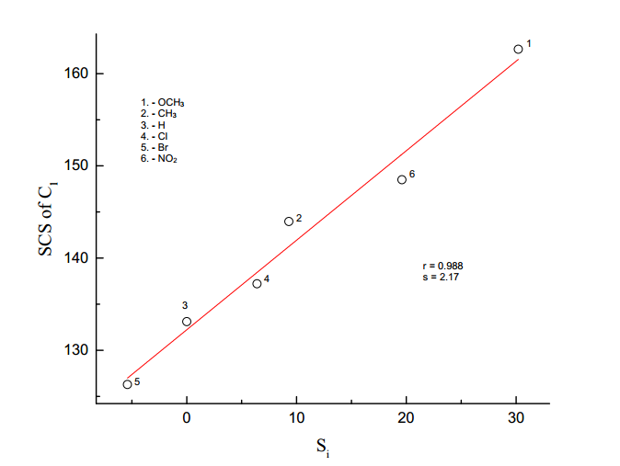

**Fig. ( ).** Lynch plot of SCS of C1 vs Si

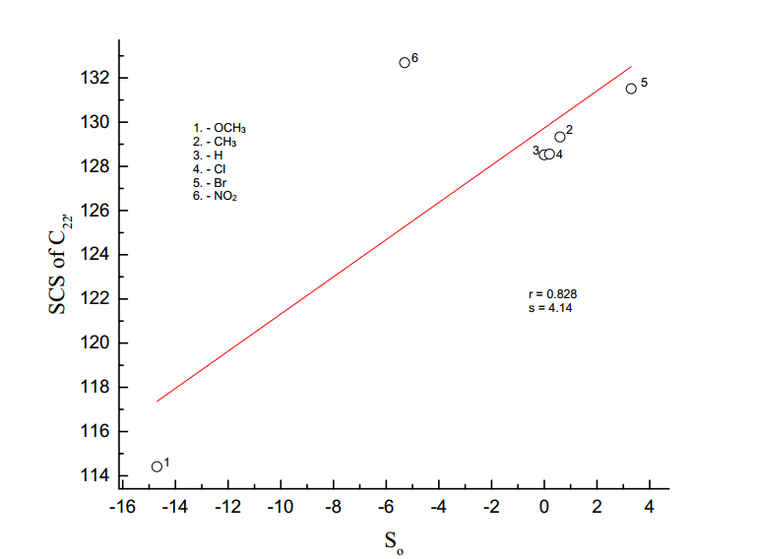

**Fig. ( ).** Lynch plot of SCS of C22’ vs So

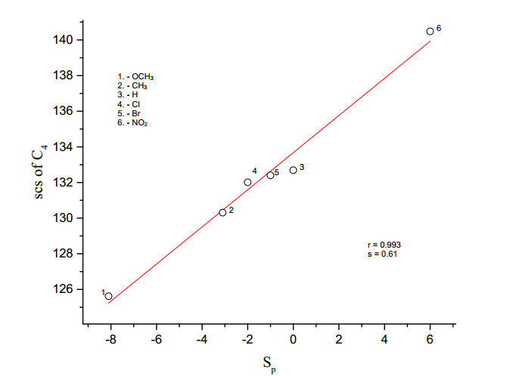

**Fig. ( ).** Lynch plot of SCS of C4 vs Sp

**Substituent effects on the 13C NMR chemical shifts of the substituted**

**5-benzulidenebarbituric acids**